**Introduction**

This assignment will demonstrate accessing data from a database through windows interface. In order to access the database, a user will be required to log into the program from the Login form. The login form will require the user to enter the correct username (admin) and password (password) to be able to access the database form. The database form will hold three entries by default, and users will be able to edit their details, add new entries and delete existing ones. Validation is carried throughout to program.

**Initial Design**

The database program is separated into two forms. The first form is a login form and the other is the database form.

**Login Form**

The login form was designed with the user in mind. It requires the user to enter the correct username and password to open the database form if the login details are valid.

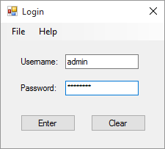

The user is able to end the program by clicking either the X in the top right or by selecting File > Exit. Both methods will show a messagebox letting the user know that the program is ending. This was added to ensure that the user knows they have ended the program and it wasn’t done by an error. Selecting Help > About will show the user another messagebox, this time informing them on who created the program.

Clicking the Clear button will clear out the text fields for Username and Password, and will then focus on the Username textbox. Clicking Enter will log the user in, but only if they have entered the correct login details. The login details entered will be checked against the ones that are assigned in Visual Basic.

While designing the login form, I made it so that the user will not be able to minimize, enlarge or change the size of the form, this was done to ensure that everything looks easy on the eye. Username and Password are labels, with text boxes beside them. When the user doesn’t enter a username or password, they are shown a messagebox informing them. This also happens when the user enters a wrong username or password.

**Database Form**

Similar to the login form, the functions for the X in the top right, selecting File > Exit and selecting Help > About are the same for the Database form. The user will also not be able to enlarge or change the size of the form.

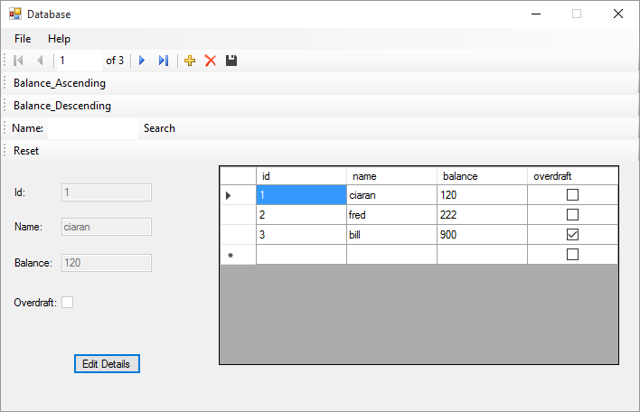

The navigation toolbar across the top of the form is added automatically by Visual Studios when adding a database. This will allow the user to select different entries, add and delete entries, and save the database.

Underneath the navigation toolbar are the queries. Balance Ascending and Balance Descending sort the entries by balance. The Name: textbox can be used to perform a search query on the database. The reset button will reset the database to its default state.

Below the queries are the textboxes used for editing the details of a currently existing entry or adding a new one. They are disabled until the user clicks the Edit Details button, this was done in order to avoid accidental edits. The database grid is also disabled to prevent the user from editing values directly and avoiding any validation required.

The validation which takes place checks if the name textbox is blank, if the balance textbox is blank, if the balance textbox is not numeric and if the overdraft is in an undetermined state (only for adding a new entry will the overdraft be in this state). When there is an invalid entry, a messagebox along with a beep will occur.

When clicking the Edit Details button or Add button, the navigation toolbar and queries are disabled in order to prevent the user from selecting any other options until they click Done or Cancel. When the Edit Details button or Add button are clicked, the Edit Details button will be hidden from view and the Done and Cancel butons will be shown. The name and balance textboxes will be enabled along with the overdraft checkbox until the user has finished.

**Program Walkthrough**

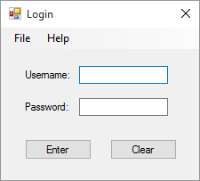

The program begins with the login screen being displayed.

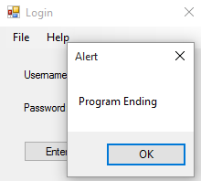

Selecting File > Exit (or clicking X) shows the user a messagebox before the program ends.

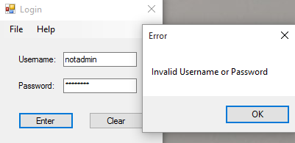

When the user enters an invalid username or password they are shown a messagebox informing them that the information entered was invalid.

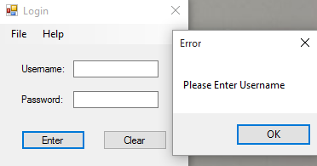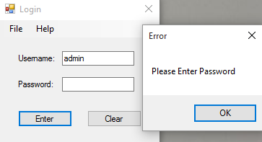

Leaving the username textbox blank will show the user a messagebox asking them to enter a username. The same is done when the password textbox is blank.



When the user clicks the Clear button, both textboxes will be reset and will focus on the username textbox.

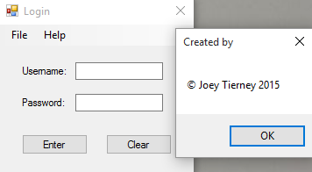

When the user clicks Help > About, a messagebox will be displayed showing the user who created the program.



Entering the right username (admin) and password (password) will hide the Login form and log the user into the database.

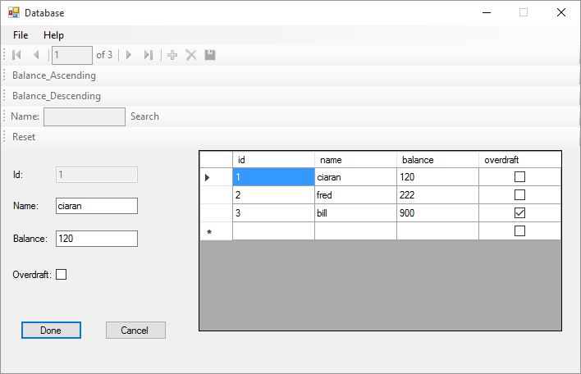

When the user clicks the Edit Details button, the button will hide and the Done and Cancel buttons will be displayed. It also disables the navigation toolstrip and the queries, it will enable the Name and Balance textboxes as well as the Overdraft checkbox.

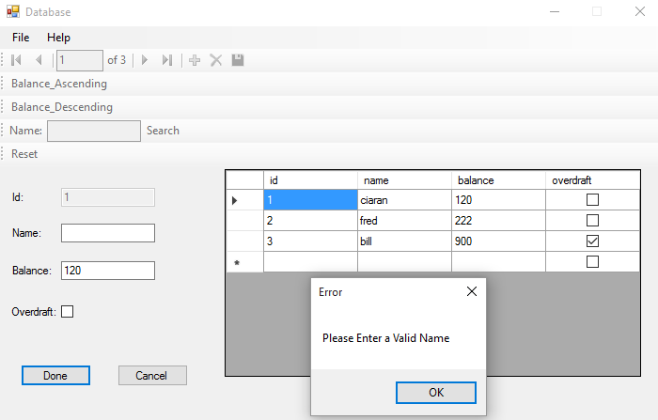

If the user leaves the Name textbox blank and they click done, a messagebox will be displayed asking the user to enter a valid name.

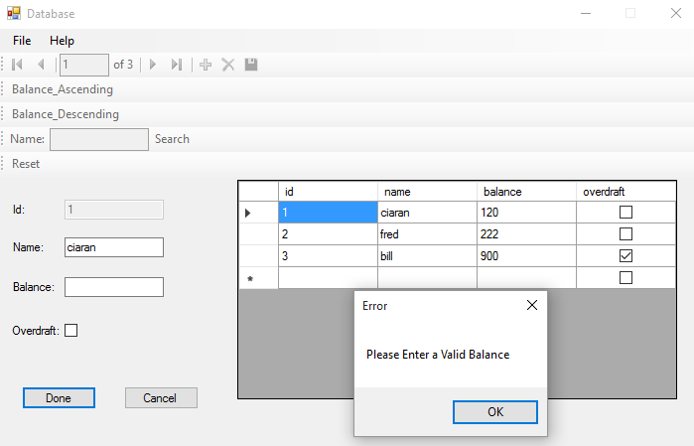 If the user leaves the Balance textbox and they click done, a messagebox is displayed asking them to enter a valid balance.

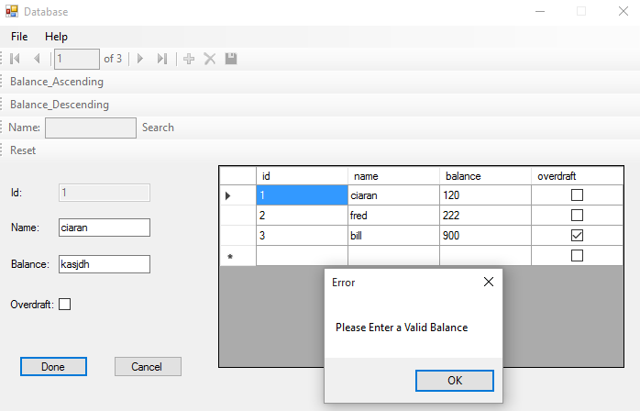

If the user enters text into the Balance textbox and they click done, a messagebox is displayed asking them to enter a valid balance.

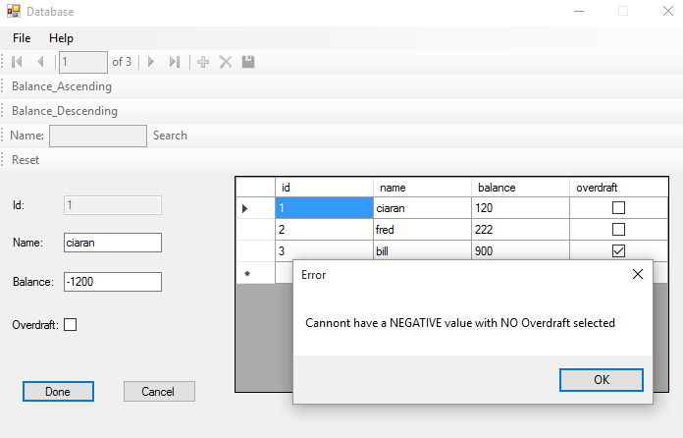

If the user enters a negative balance with no overdraft option selected, a messagebox is shown informing the user that they must have an overdraft.

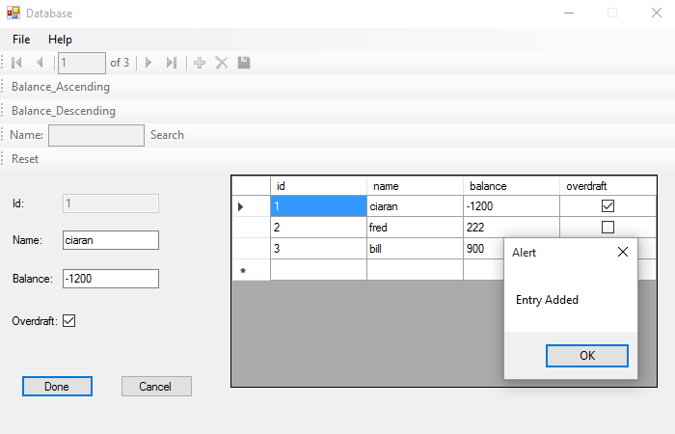

Clicking done will display a messagebox telling the user that the entery was added. The database will then be updated with the details entered. When the messagebox is gone, the Done and Cancel buttons will be hidden and the Edit Details button will be shown, the Name, Balance and Overdraft will be disabled and the navigation bar and queries will be enabled.

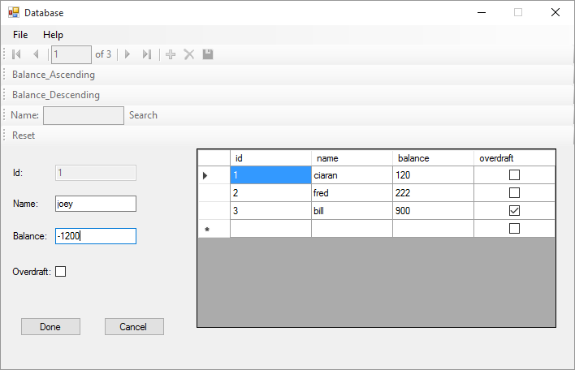

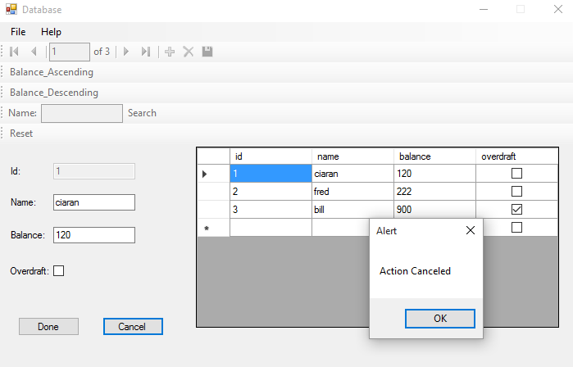

While editing, if the user clicks cancel, a messagebox will be displayed telling the user that the action was cancelled, and the Name and Balance textboxes will be reset to their defaults before editing took place. When the messagebox is gone, the Done and Cancel buttons will be hidden and the Edit Details button will be shown, the Name, Balance and Overdraft will be disabled and the navigation bar and queries will be enabled.

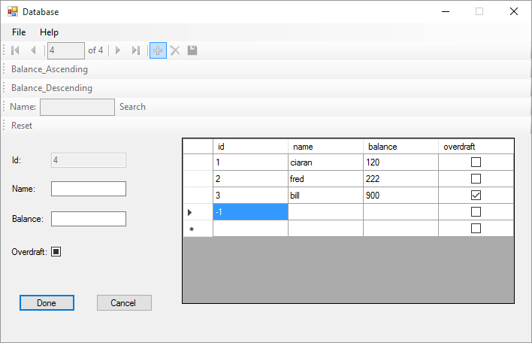

When the user clicks the add button, the Edit Details button will be hidden and the Done and Cancel buttons will be displayed. The navigation and the queries will all be disabled, and the Name, Balance and Overdraft fields will be enabled. The Id textbox remains disabled.

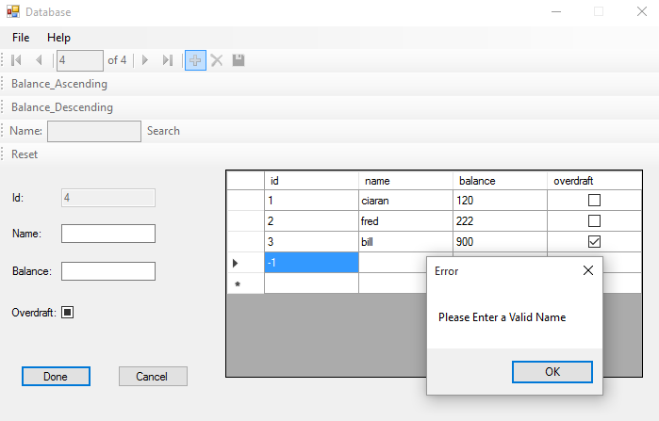

If the user leaves the Name textbox blank and they click done, a messagebox will be displayed asking the user to enter a valid name.

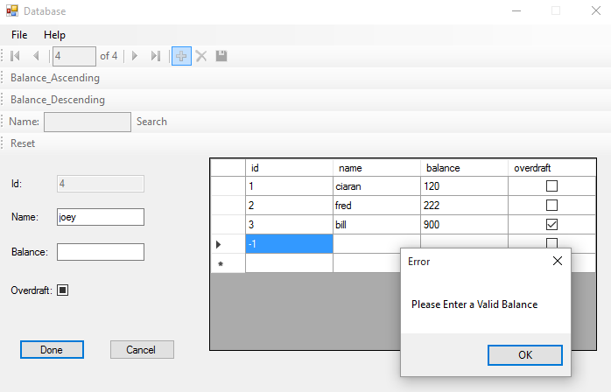

If the user leaves the Balance textbox and they click done, a messagebox is displayed asking them to enter a valid balance.

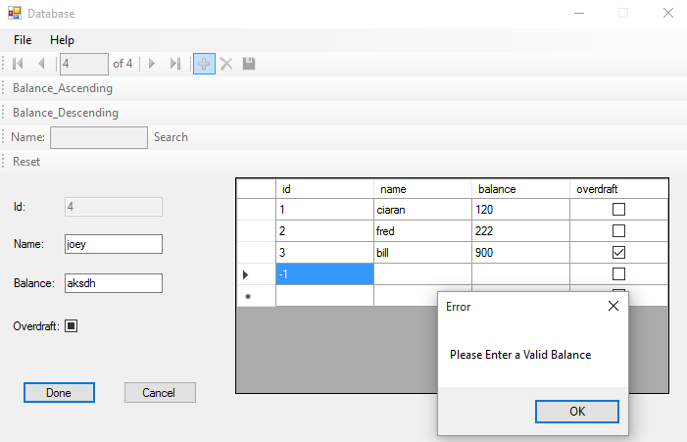

If the user enters text into the Balance textbox and they click done, a messagebox is displayed asking them to enter a valid balance.

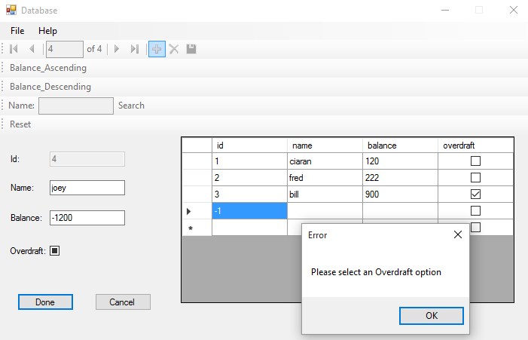

If the user leaves the Overdraft checkbox in an undetermined state, they are shown a messagebox asking them to select an overdraft option.

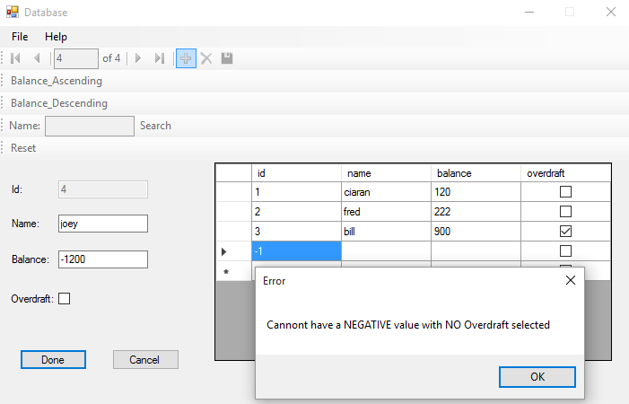

If the user enters a negative value and they don’t have overdraft selected, they are shown a messagebox telling them they need to select an overdraft.

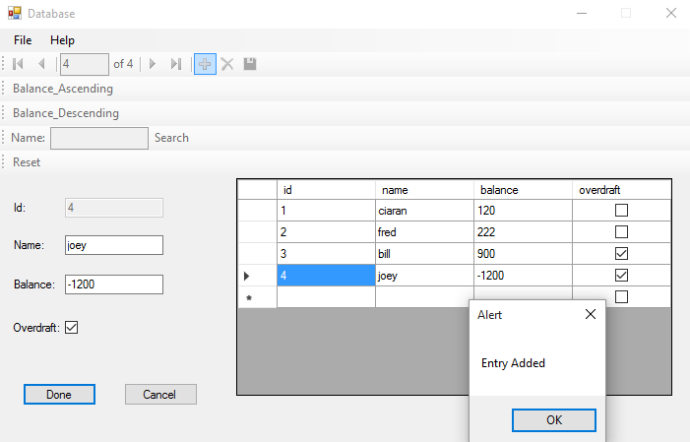

Clicking done will add the entry to the database and display a messagebox informing the user that it has done so. When the messagebox is gone, the Done and Cancel buttons will be hidden and the Edit Details button will be shown, the Name, Balance and Overdraft will be disabled and the navigation bar and queries will be enabled.

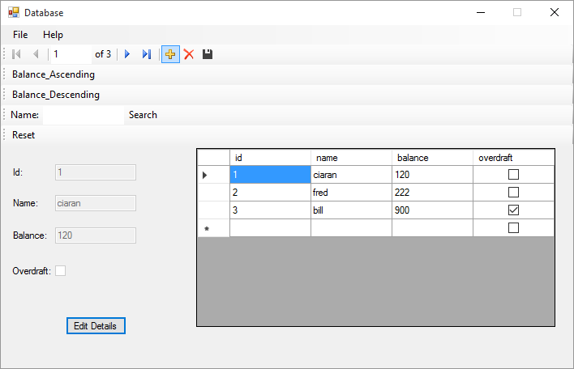

When the user clicks Balance Ascending, the database will reset to its default state and sort the fields in ascending order from Balance.

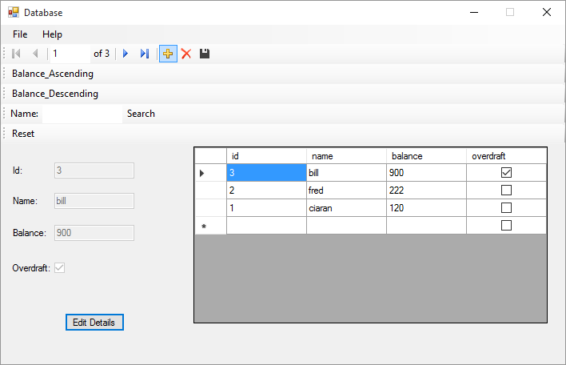

When the user clicks Balance Descending, the database will sort the fields in descending order from the balance.

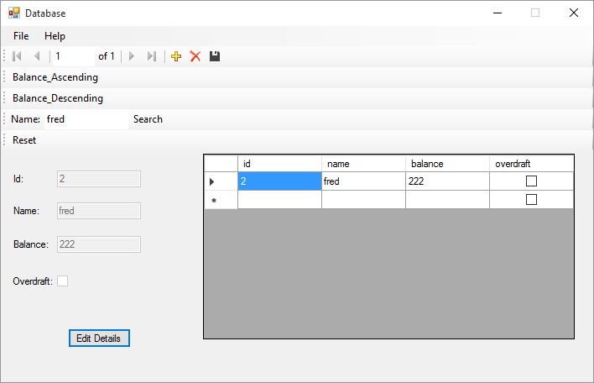

When the user enters a name that exists in the database and clicks search, the database will show them that specific entry.

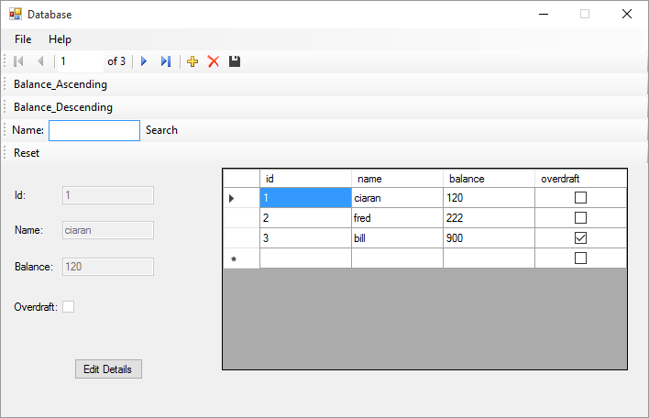

Clicking reset clears the search field and resets the database to its original version.

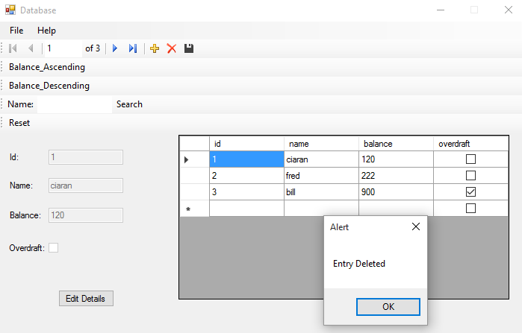

Clicking the delete button will display a messagebox informing the user that the selected entry has been deleted, when the messagebox is gone the database will update with the selected entry deleted.

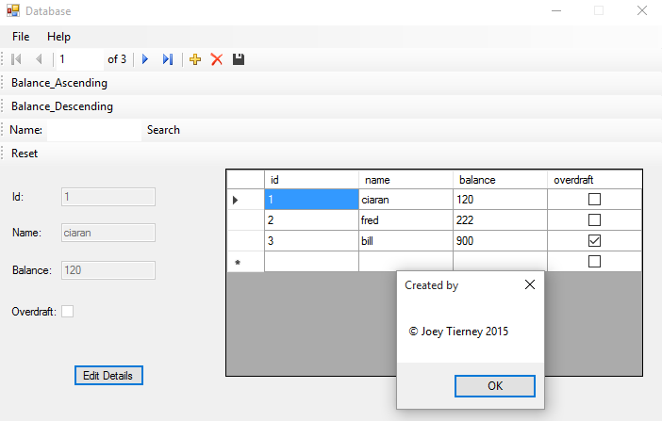

Clicking Help > About will show a messagebox to the user showing them who the program is made by.

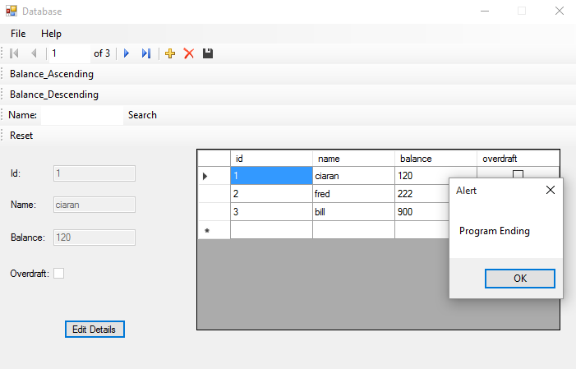

Clicking File > Exit (or the X) will show the user a messagebox before the program ends.

**Test Bed**

|  |  |
| --- | --- |
| Action | Result |
| Login Form | |
| Enter Button | |
| Empty Username textbox entry | Beep. Messagebox: “Please Enter Username”  Focus on Username textbox |
| Empty Password textbox entry | Beep. Messagebox: “Please Enter Password”  Focus on Password textbox |
| Invalid Username or Password | Beep. Messagebox: “Invalid username or password”  Focus on Username textbox |
| Valid Username and Password | Hide login form and show database form |
| Clear Button | |
| Any values in either textbox | Clear both textboxes. Focus on Username textbox |
| File > Exit and ‘X’ | |
| Any values in either textbox | Beep. Messagebox. “Program Ending”  Program ends |
| Help > About | |
| Any values in either textbox | Messagebox: “Joey Tierney 2015” |
| Database Form | |
| Move first | Moves database selection to first entry |
| Move previous | Moves database selection to previous entry |
| Move next | Moves database selection to next entry |
| Move last | Moves database selection to last entry |
| Delete | Beep. Messagebox: “Entry deleted”. Entry removed from database |
| Add new | Adds new entry to database |
| Balance Ascending | Sorts database entries by balance, lowest to highest |
| Balance Descending | Sorts database entries by balance, highest to lowest |
| Search | Displays database entries whose name field matches the text entered in the search name textbox |
| Reset | Resets the database to its default state |
| Edit Details | Allows the user to edit the name, balance and overdraft fields of the currently selected database entry. Replaces Edit Details button with Done and Cancel buttons. |

**Conclusion**

Overall, the program works as intended and the test bed results match with the expected outcomes. Problems early on in the assignment included setting the Cancel button on the database form to reset itself to the last save state it was in, however this was fixed later on by adding the temp1 and temp2 variables.